**CSV Guide-**

**id**: Identifier for which farm is chosen.

**source**: Who supplied the image? A = AgResource, P = Public

**farm**: Name of the farm for display over the picture.

**photos_no**: Total amount of photos you have for a given farm.

**latitude**: latitude of the given farm

**longitude**: longitude of the given farm

**date_1, date_2, ... , date_n**: The corresponding date for each photo. You should be able to add as many of these columns as you need. If date is unknown or undesired for a given photo/time, leave cell blank.

**Updating the Data**

First we’ll need to convert the CSV to a geojson. This is necessary because we need to make sure the Lat & Long values can be appropriately translated into Leaflet and the rest of the data easily accessible.

There are a few sites that can perform the conversion for us, all of which come up easily enough with a search for “CSV to Geojson”. For this map, I used the service provided here:

<http://ogre.adc4gis.com/>

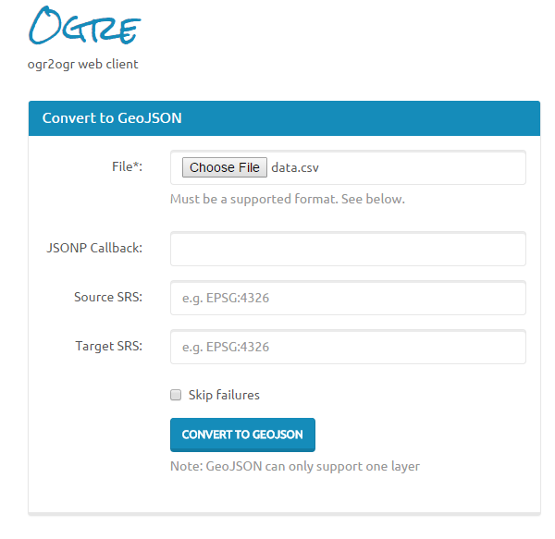

Just choose the file and hit the big button that says ‘CONVERT TO GEOJSON’. It should take you to a new page with the geojson on it. Copy that and move over to the main.js file.

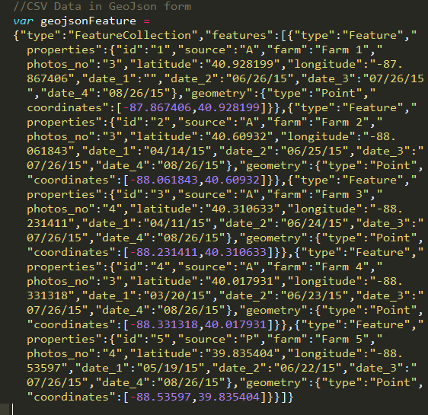

Jump down a lines to the var geojsonFeature =, and replace all that text with your updated dataset.  
  
The map will then immediately update to the new information.

**Adding new photos/farms**

To add new photos, first go into the Data.CSV and update the amount of photos (**photos_no** value) for each farm you’re adding to.

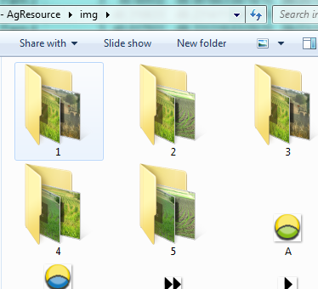

The photos are stored in the **img** folder, with folders corresponding to the farms id value. If you add new farms, you’ll need to create a new folder for it.

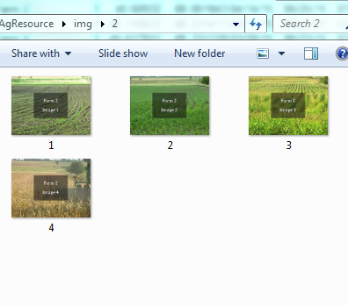

Inside the folders, the images should be put inside, in sequential order.

Once those are uploaded to the server, everything should display fine!